Project Design Phase-II
Data Flow Diagram & User Stories

Date | 31 January 2025
Team ID
Project Name
Maximum Marks | 4 Marks

Data Flow Diagrams:
A Data Flow Diagram (DFD) is a traditional visual representation of the information flows within a system. A neat and clear DFD can depict the right amount of the system requirement graphically. It shows how data enters and leaves the system, what changes the information, and where data is stored.
Example: 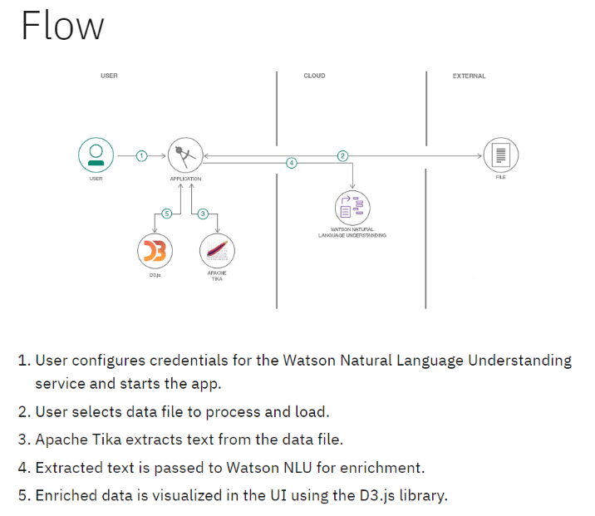 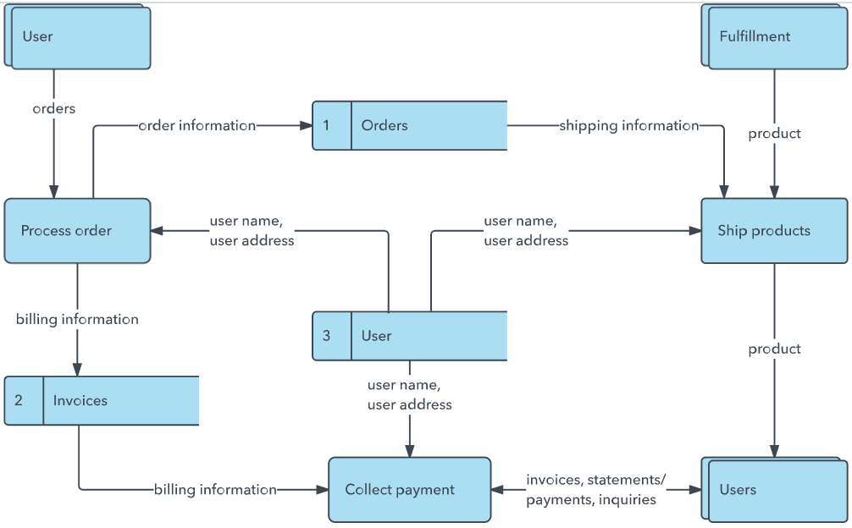 User Stories
Use the below template to list all the user stories for the product.
User Type | Functional Requirement (Epic) | User Story Number | User Story / Task | Acceptance criteria | Priority | Release
Customer (Mobile user) | Registration | USN-1 | As a user, I can register for the application by entering my email, password, and confirming my password. | I can access my account / dashboard | High | Sprint-1
Customer (Mobile user) | Registration | USN-2 | As a user, I will receive confirmation email once I have registered for the application | I can receive confirmation email & click confirm | High | Sprint-1
Customer (Mobile user) | Registration | USN-3 | As a user, I can register for the application through Facebook | I can register & access the dashboard with Facebook Login | Low | Sprint-2
Customer (Mobile user | Registration | USN-4 | As a user, I can register for the application through Gmail | I can register & access the dashboard via Gmail OAuth | Medium | Sprint-1
Customer (Mobile user | Login | USN-5 | As a user, I can log into the application by entering email & password | I can access my dashboard securely with correct credentials | High | Sprint-1
Customer (Mobile user | Dashboard | USN-6 | As a user, I can view my profile details, recent activities, and saved blog items on my dashboard. | I can successfully view my dashboard overview stats and user panel items | Medium | Sprint-1
Customer (Web user) | Blog Management | USN-7 | As a web user, I can view, read, and search through published blog articles. | I can browse blog feeds, view full content, and use search filters | High | Sprint-1
Customer (Web user ) | Commenting | USN-8 | As a web user, I can post comments and responses under blog posts. | My comment is successfully added and displayed beneath the post | Medium | Sprint-2
Customer Care Executive | Comment Moderation | USN-9 | As an editor, I can review, approve, flag, or delete user comments. | Inappropriate comments are pruned and valid comments are published | High | Sprint-2
Administrator | User Management | USN-10 | As an admin, I can manage user database registrations and update role assignments. | User roles can be changed between Admin, Editor, Author, and Reader | High | Sprint-1
Administrator | System Logs | USN-11 | As an admin, I can inspect full logging entries and system analytics metrics. | I can view complete dashboard reports. | Low | Sprint-2

